Task 5.4: (Syllabus Task 11) Implement a Data Access Layer using Spring Data JPA use JpaRepository and custom query methods to
retrieve student records based on conditions such as department or age.
STEP 1: Create Spring Boot Project
Project Details:
- Project: Maven
- Language: Java
- Spring Boot: (latest)
- Group: com.example
- Artifact: studentapp
- Package: com.example.studentapp
Add Dependencies:
Spring Web
Spring Data JPA
MySQL Driver
Click Finish
Project Structure Image:
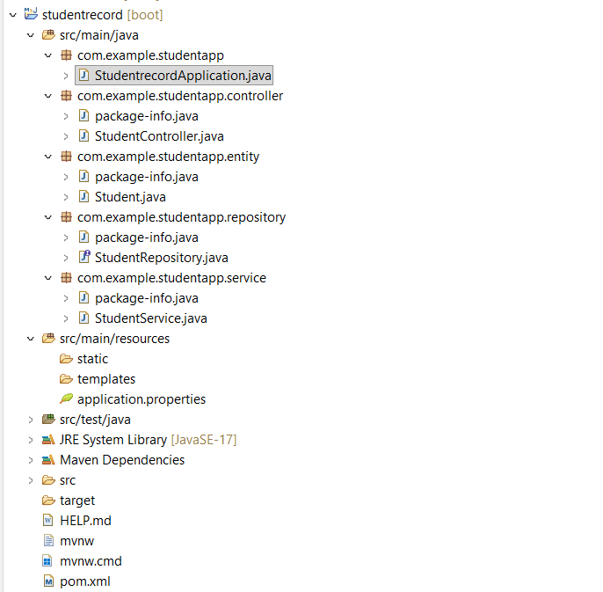
STEP 2: Configure Database
src/main/resources/application.properties
spring.application.name=studentrecord
spring.datasource.url=jdbc:mysql://localhost:3306/studentdb
spring.datasource.username=root
spring.datasource.password=computer
spring.jpa.hibernate.ddl-auto=update
spring.jpa.show-sql=true

created database in MySQL:
CREATE DATABASE studentdb;

STEP 3: Create Entity Class (Table Mapping)
Create package:
com.example.studentapp.entity
Create class: Student.java
package com.example.studentapp.entity;
import jakarta.persistence.*;
@Entity
@Table(name = "students")
public class Student {
@Id
@GeneratedValue(strategy = GenerationType.IDENTITY)
private Long id;
private String name;
private String department;
private int age;
public Student() {}
public Student(String name, String department, int age) {
this.name = name;
this.department = department;
this.age = age;
}
// Getters and Setters
public Long getId() { return id; }
public void setId(Long id) { this.id = id; }
public String getName() { return name; }
public void setName(String name) { this.name = name; }
public String getDepartment() { return department; }
public void setDepartment(String department) { this.department = department; }
public int getAge() { return age; }
public void setAge(int age) { this.age = age; }
}
STEP 4: Create Repository (Data Access Layer)
Create package:
com.example.studentapp.repository
Create interface: StudentRepository.java
package com.example.studentapp.repository;
import java.util.List;
import org.springframework.data.jpa.repository.JpaRepository;
import org.springframework.stereotype.Repository;
import com.example.studentapp.entity.Student;
@Repository
public interface StudentRepository extends JpaRepository<Student, Long> {
List<Student> findByDepartment(String department);
List<Student> findByAgeGreaterThan(int age);
}
STEP 5: Create Service Layer
Create package:
com.example.studentapp.service
Create class: StudentService.java
package com.example.studentapp.service;
import java.util.List;
import org.springframework.beans.factory.annotation.Autowired;
import org.springframework.stereotype.Service;
import com.example.studentapp.entity.Student;
import com.example.studentapp.repository.StudentRepository;
@Service
public class StudentService {
@Autowired
private StudentRepository studentRepository;
public Student saveStudent(Student student) {
return studentRepository.save(student);
}
public List<Student> getAllStudents() {
return studentRepository.findAll();
}
public List<Student> getStudentsByDepartment(String dept) {
return studentRepository.findByDepartment(dept);
}
public List<Student> getStudentsByAge(int age) {
return studentRepository.findByAgeGreaterThan(age);
}
}
STEP 6: Create Controller
Create package:
com.example.studentapp.controller
Create class: StudentController.java
package com.example.studentapp.controller;
import java.util.List;
import org.springframework.beans.factory.annotation.Autowired;
import org.springframework.web.bind.annotation.*;
import com.example.studentapp.entity.Student;
import com.example.studentapp.service.StudentService;
@RestController
@RequestMapping("/students")
public class StudentController {
@Autowired
private StudentService studentService;
@PostMapping
public Student addStudent(@RequestBody Student student) {
return studentService.saveStudent(student);
}
@GetMapping
public List<Student> getAllStudents() {
return studentService.getAllStudents();
}
@GetMapping("/department/{dept}")
public List<Student> getByDepartment(@PathVariable String dept) {
return studentService.getStudentsByDepartment(dept);
}
@GetMapping("/age/{age}")
public List<Student> getByAge(@PathVariable int age) {
return studentService.getStudentsByAge(age);
}
}
STEP 7: Run Application
Run:
StudentappApplication.java
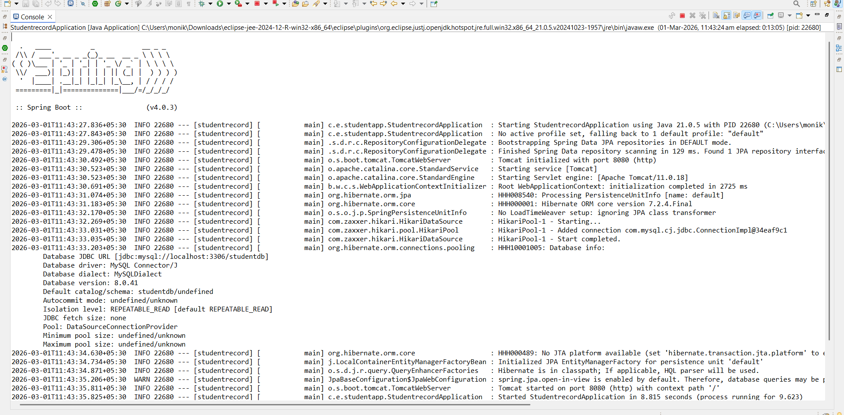
STEP 8: Test in Postman
POST

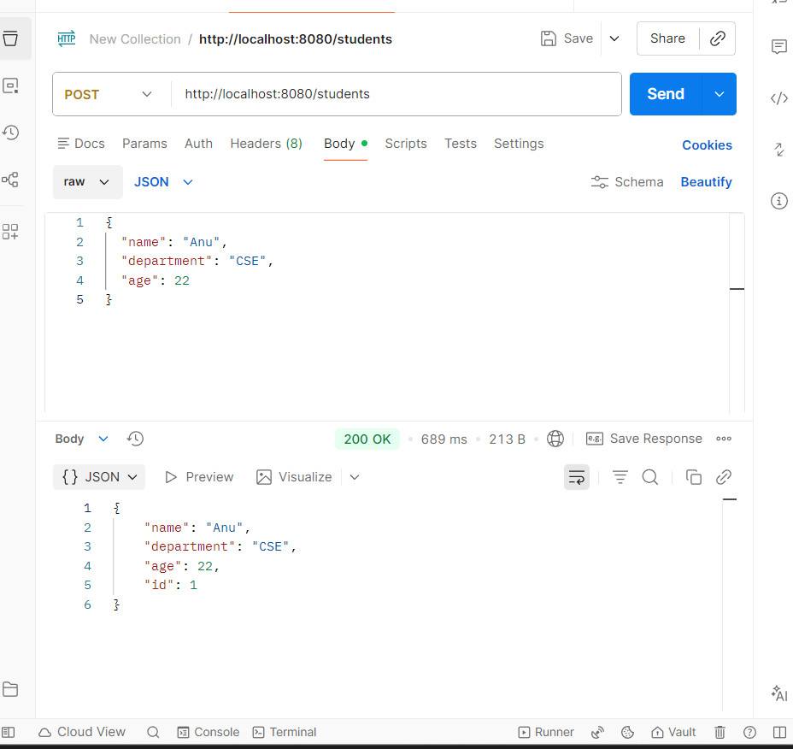
Get By Department
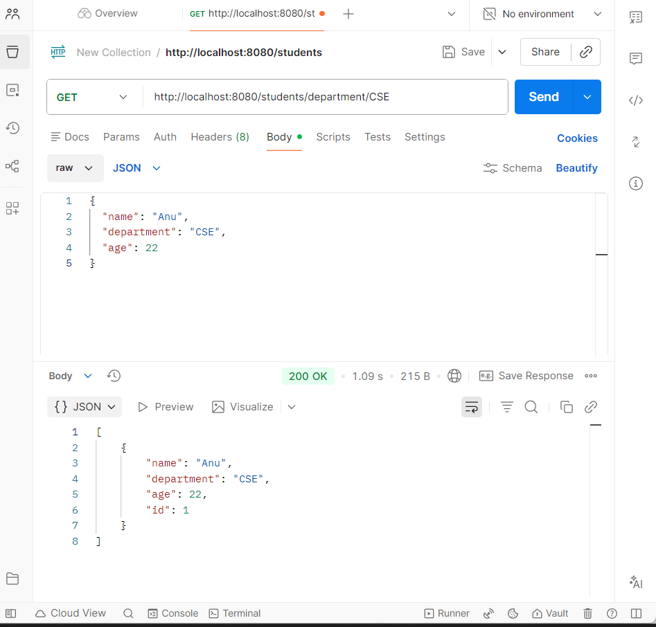
Get By Age > 20
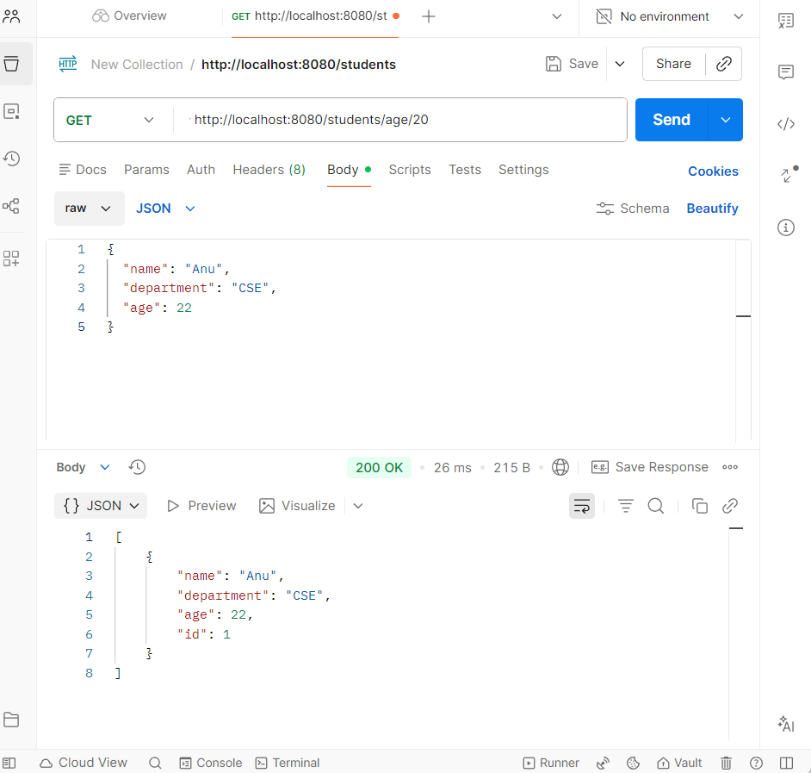
STEP 9: In mysql

